Daniel 6 – Daniel prays

Let’s make some praying hands.
Draw around your child’s hand, cut them out, write ‘I can pray like Daniel’ and get your child to decorate them. Once they are decorated you could leave them as they are or stick them together like this. Put the somewhere you’ll all keep seeing them as a reminder to keep praying.

Prayer guides
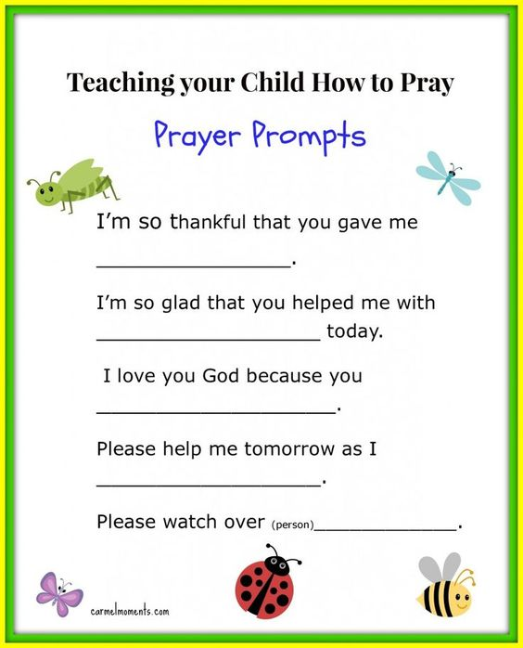
Use the guide to help your child to pray or the prayer prompts including in this pack.

We have use TSP (teaspoon) prayers in Vkids

T – thank you

S – sorry

P – please
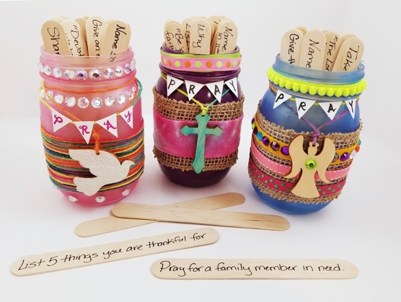
A Prayer Jar

Find an old jam jar to make into your family prayer jar. Decorate your jar. You could use;
- Sharpies
- Mod podge and tissue paper
- Ribbons

As a family chat about prayer whilst making the jar. You could ask questions like;
- Why did Daniel choose to pray to God and not the king?
- Daniel prayed to God even though he knew what might happen to him?
- Did he hide in his room to pray?

Once you have decorated your prayer jar. Take the lolly sticks and write prayer prompts like;
- Pray for someone you know who is sick
- List 5 things you are grateful for
- Share something God has done/shown you this week
- Take a minute to stay silent to reflect

You could also add some memory verses too. Here’s some suggestions:

“Be joyful in hope, patient in affliction, faithful in prayer.” (Romans 12:12)
“And pray in the Spirit on all occasions with all kinds of prayers and requests. With this in mind, be alert and always keep on praying for all the Lord’s people.” (Ephesians 6:18)

“The LORD is near to all who call on him, to all who call on him in truth.” (Psalm 145:18)
“Then Jesus told his disciples a parable to show them that they should always pray and not give up.” (Luke 18:1)
“Do not be anxious about anything, but in every situation, by prayer and petition, with thanksgiving, present your requests to God.” (Philippians 4:6)
“Devote yourselves to prayer, being watchful and thankful.” (Colossians 4:2)
“Be joyful always; pray continually; give thanks in all circumstances, for this is God’s will for you in Christ Jesus” (1 Thessalonians 5:16-18).
“And God is able to bless you abundantly, so that in all things at all times, having all that you need, you will abound in every good work.” (2 Corinthians 9:8)

Discussion for older VKids.
I call you to, God, and you answer me’

Psalm 17 v6

